**A Manual for Employee Machine Monitoring System**

**Login Page:**

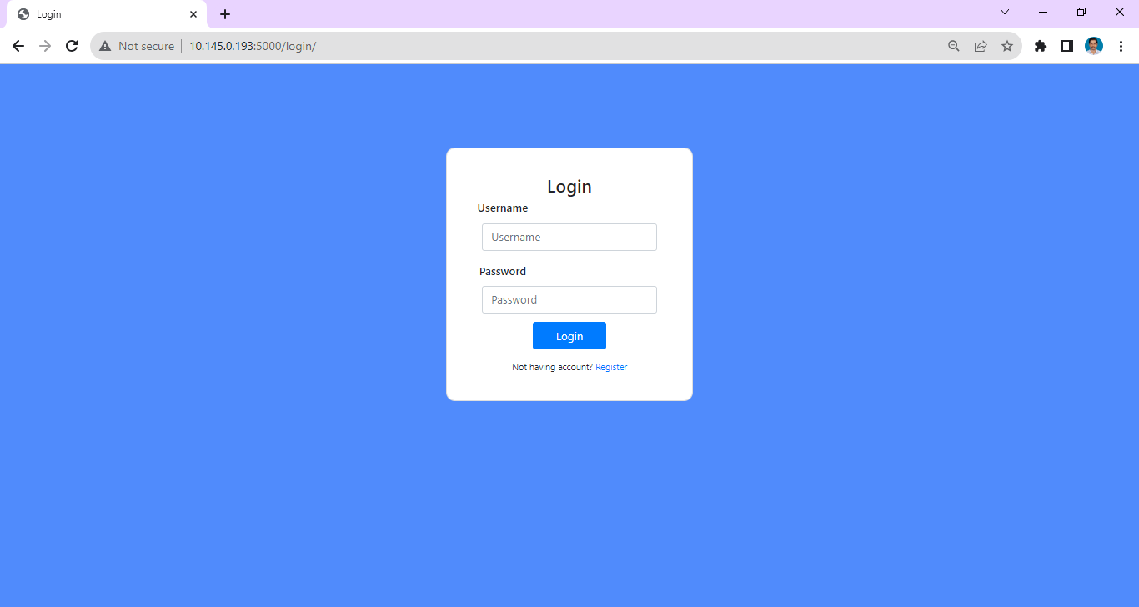

The first screen is the login screen. The primary user is Admin. The Admin password cannot be changed and it can be modified only from the Database. Admin can create as many users with specific roles as possible. The Admin can specifically create the “IT-Role” role wherein the IT-Role can create all other users.

**Dashboard:**

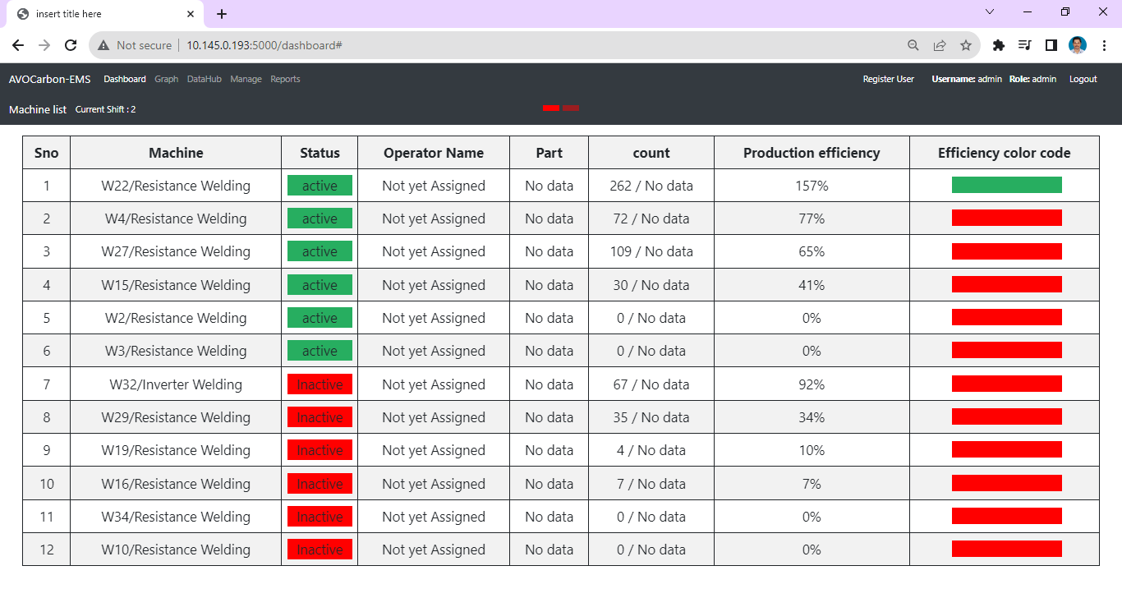

After successful login, the first screen is the Dashboard that has the Current shift, Serial Number, Machine name, Status of the machine (Active / inactive), the operator name, if it is assigned by the supervisor, the part number, the count that the operator is performing in a particular shift, production efficiency and the efficiency color code based on the current shift as indicated in the webpage. The “Active” machines will be displayed at the top and then the “Inactive” machines. They are sorted based on the higher efficiency levels. For every five minutes, this dashboard will get auto refreshed. The page will get auto scrolled for every 10 second and it can also be manually scrolled by pressing the top, right and left buttons.

**Graph:**

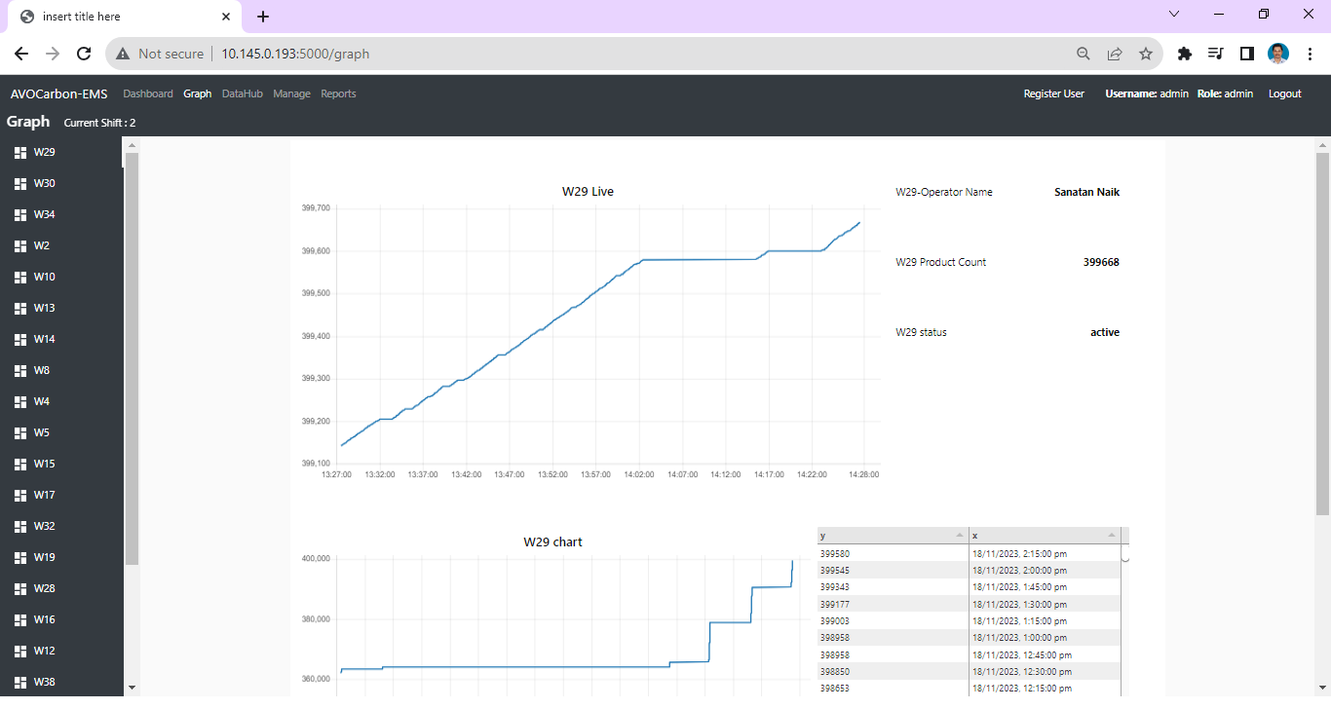

The tab next to dashboard is the Graph tab. The graph shows the Live data and the left corner of the Graph screen shows the number of machines that are currently in use. The right top corner shows the machine count and the machine status. The right bottom shows the legend that shows the historical data / value from the start time of the machine on a hourly basis to till this hour.

**Data Hub:**

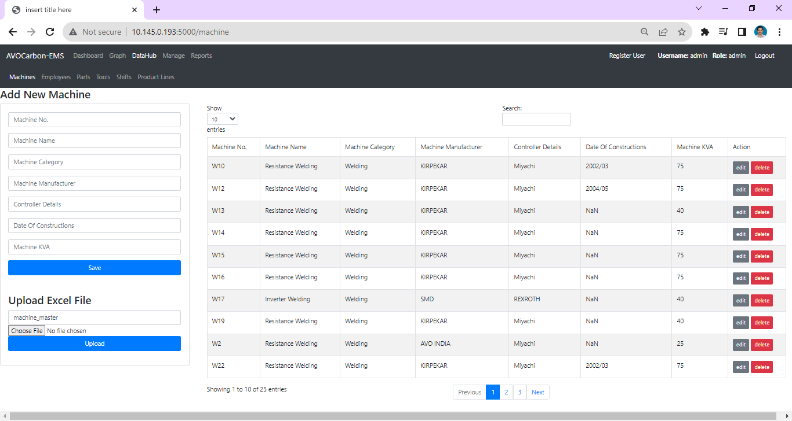

The datahub tab has six internal tabs such as machines, employees, parts, tools, shift and product line. In the machine, employees, parts, tools and the product line both manual entry and upload from Excel file is also made possible. But the excel file should be in a specific format only. To know the format, navigate to the help documents tab under the sample templates you can find the templates. Each sub tab can be filled with the respective numbers, names, categories and the details as per the individual requirement of the tabs.

The “Part” tab will contain the usual fields that is to be filled and after filling the same, it has an exclusive tolerance value. The tolerance value has to be fixed by the Supervisor. The default tolerance value specified is 5. For example, if the tolerance value is given as 10, then the range between 90 – 110 will have an Orange color and above 110% it will give the Green color and below 90% it will show the Red color.

**Shift (Sub Tab):**

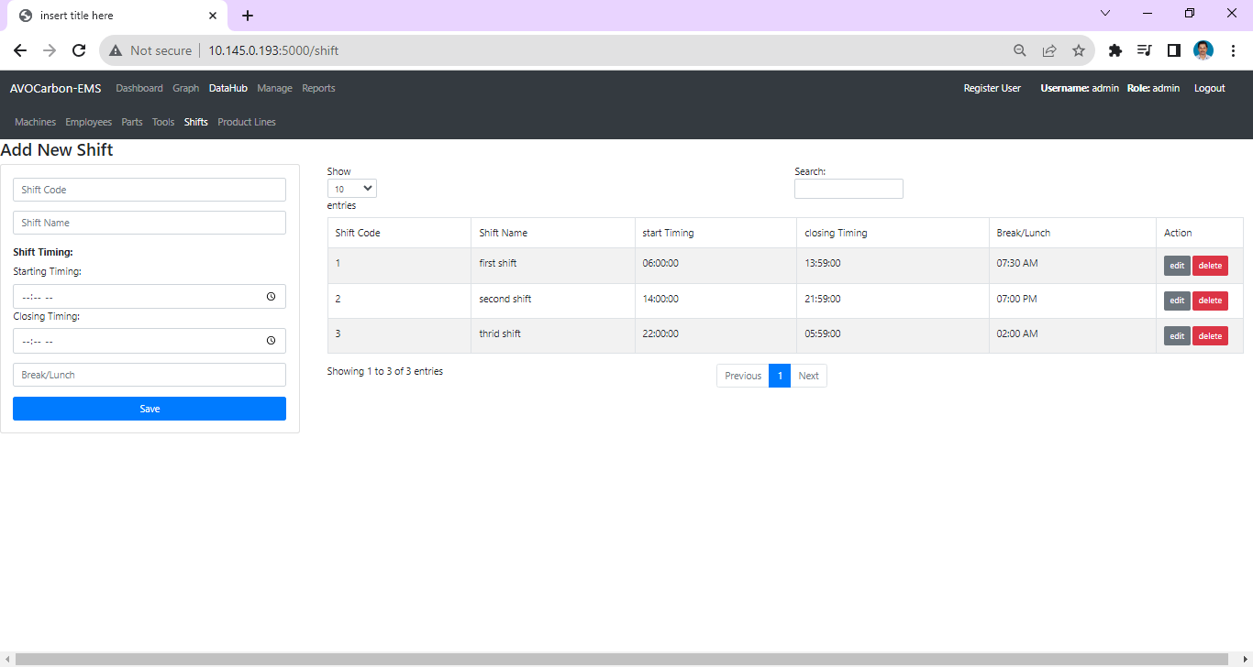

The Shift tab is one of the critical tab, which means the IT-Role have to give the input correctly. For example, if the Shift 1 is between 6 AM and 2 PM, then he has to give the values between 06:00 AM and 1:59 PM and the second shift should be given as, 02:00 PM and 09:59 PM and likewise.

**Manage:**

**Operator Assignment:**

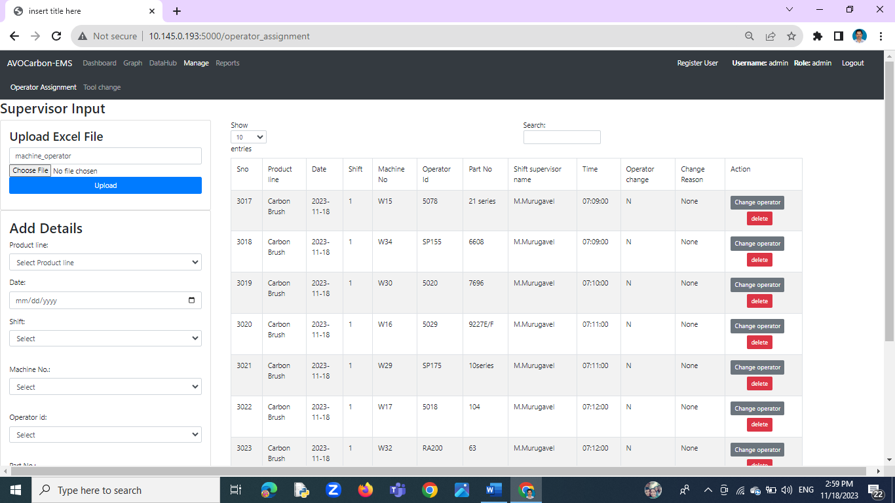

It is the responsibility of the Supervisor to enter the details of operators such as the part number, product line, machine number, operator name and the shift details.

**Tool change:**

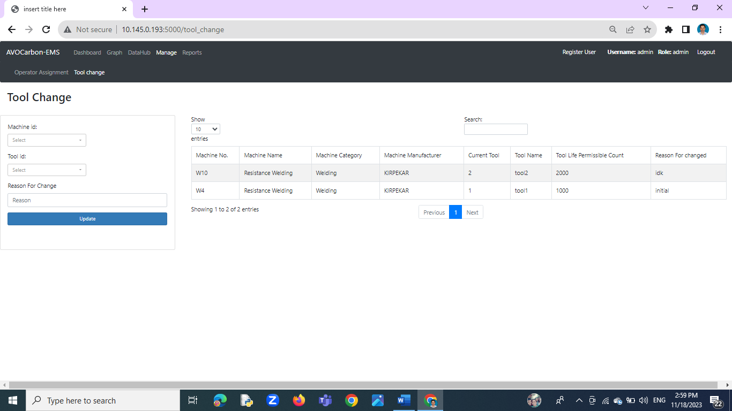

This sub tab will be under the Manage tab which will shows the details of “Tool Change”. This tab shows the details of what tool is used and in which machine that particular tool is used.

**Report:**

The Report tab contains two sub tabs. One is the Report Generation tab and the other is the Hourly Tab.

**Report Generation:**

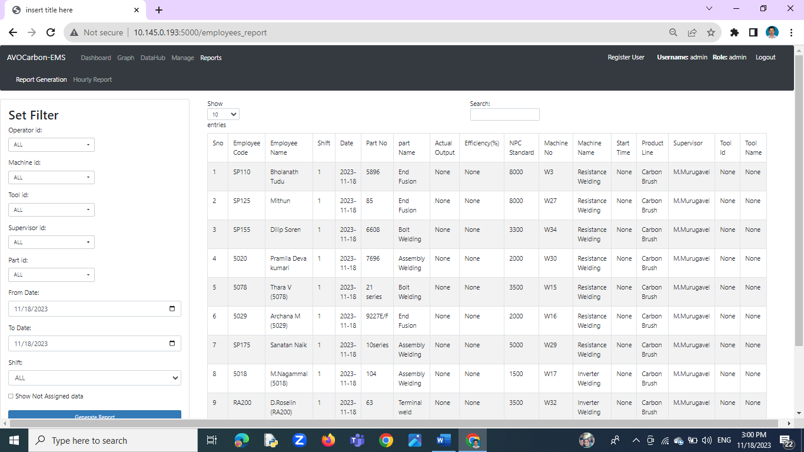

He Report Generation screen has the Filter option and it contains details about operator Id, machine ID, Tool ID, Part ID, From_Date, To_Date and the Shift details. When all these details are inputted, the desired report will be obtained. This page contains the Show drop down button option that will contain details such as how many records need to be shown, viz., 1, 10, 100, 1000, All. Further, Search option is kept to search the required fields. The Previous page and the Next page navigation buttons are kept at the center bottom of the page.

The report will also display the respective Color codes based on the performance and efficiency of the operators.

**Hourly Report:**

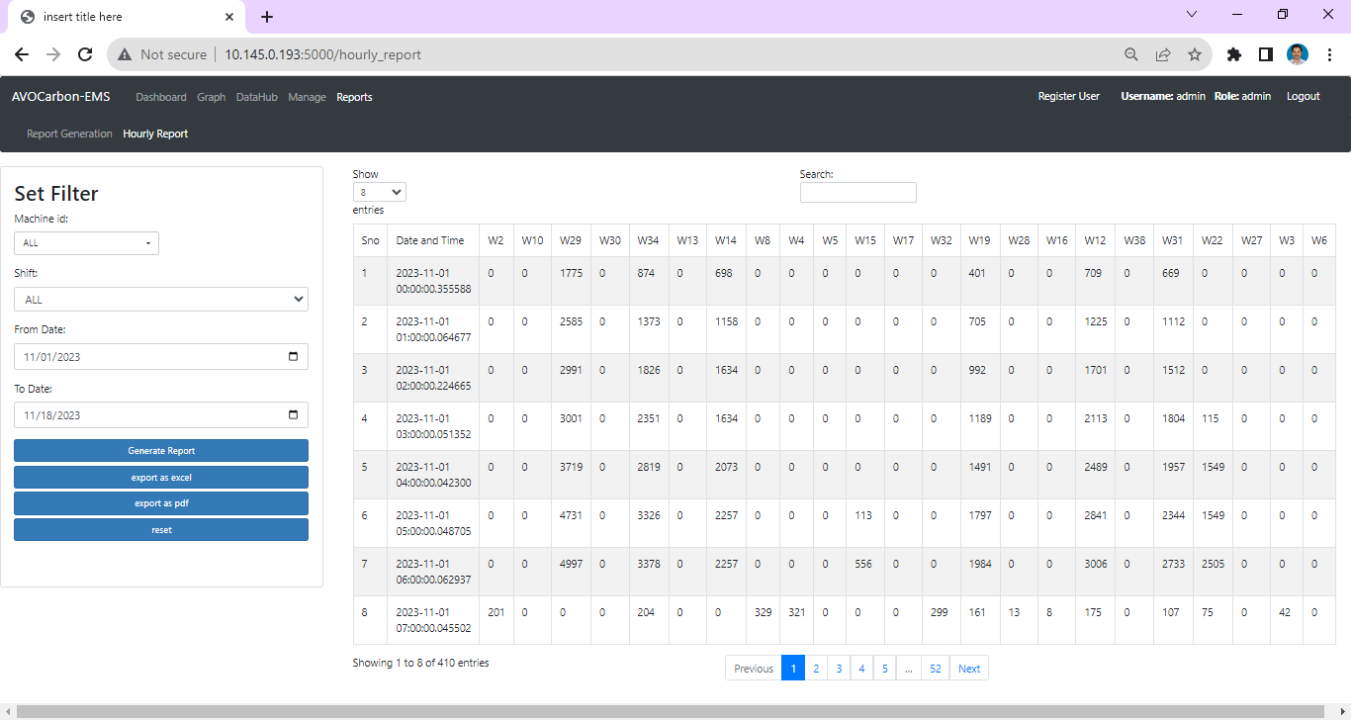

This tab “Hourly Report” shows the per hour data. This screen has filters such as machine ID, Shift, From_Date, To_Date can be selected. This Hourly report can be exported in the form of Excel or PDF formats as per the need of the user.

**Register User:**

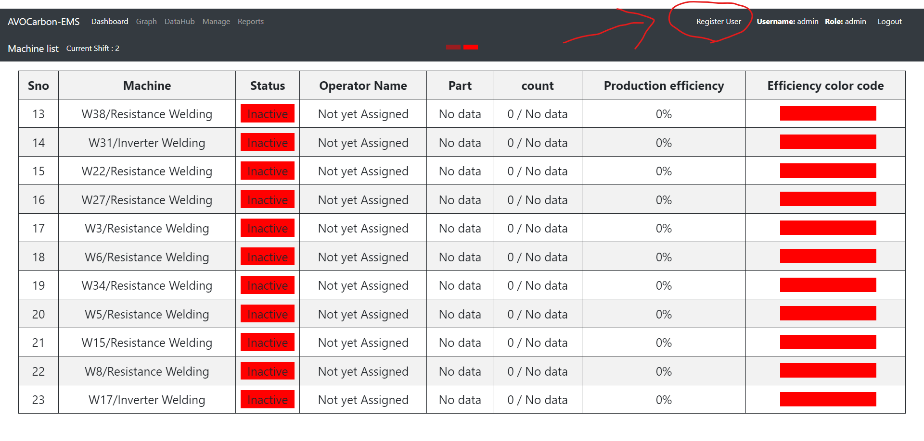

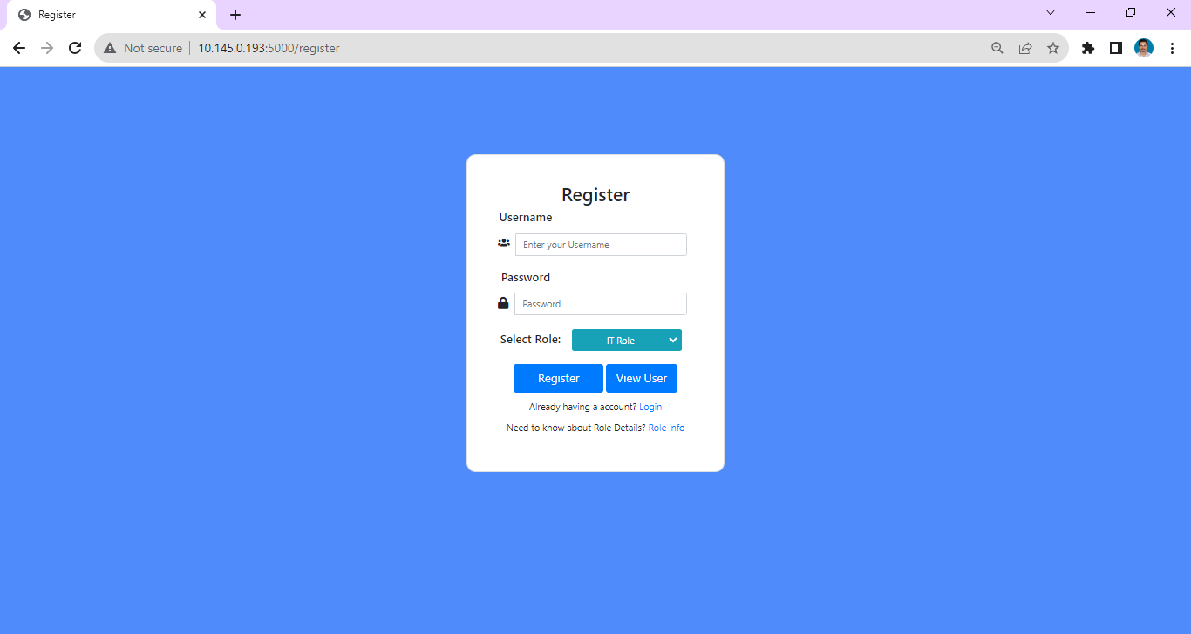

This is a specific tab which is enabled only for Admin and IT-Role and others cannot access the same. The admin can create as many users as possible. The Admin is the super user who can create the IT – Role and the IT-Role user can create other users such as IT-Role, Hr, Supervisor and Viewer.

**View User:**

The View User button will display all the users associated with the system. Any user other than the Admin could be deleted from this page.

**Role Info:**

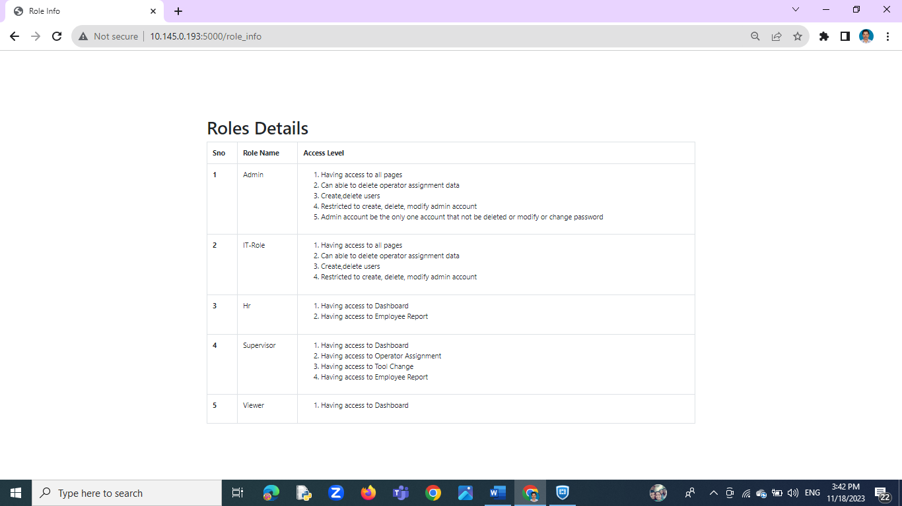

The Role Info which is kept below the View User button will give details about the Roles and Responsibilities of each user.

**Logout:**

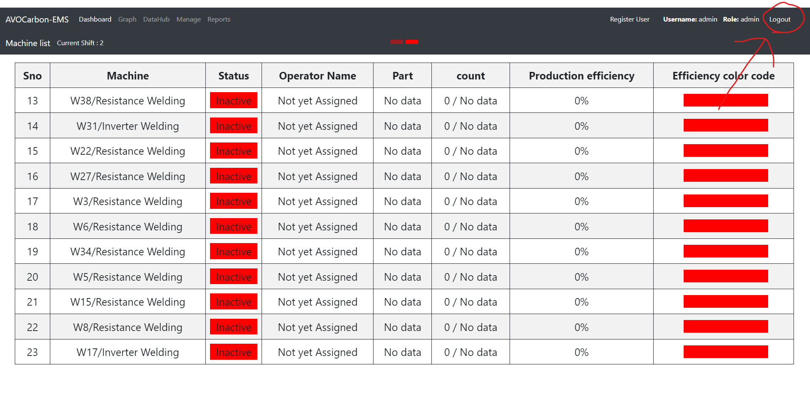

The Logout button when pressed logs out from the web page.